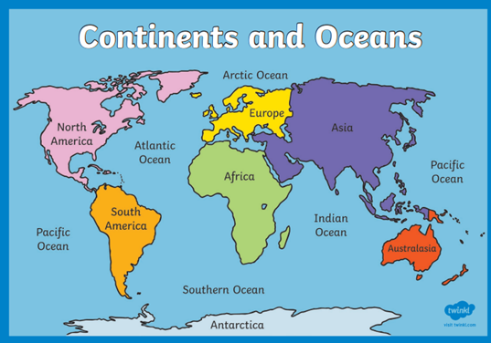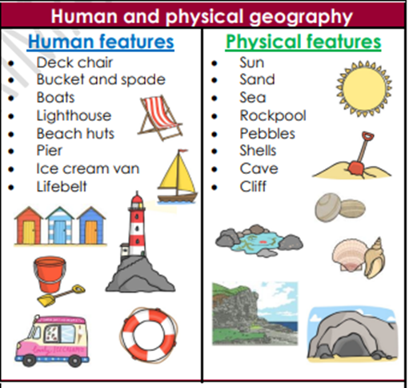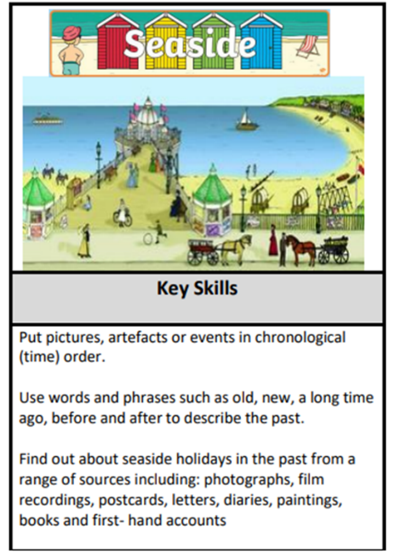Beside the seaside

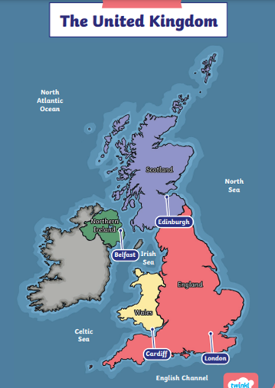

|  |  |
| --- | --- |
| seaside | a place by the sea that is usually a beach area or holiday resort |
| coast | where the land meets the sea |
| island | an area of land surrounded by water |
| resort | a place where people go on holiday |
| pier | a structure built out from the land for people to walk on |
| promenade | a walkway along the seafront |
| bathing machine | these were used so people could get changed in private |

**Grace Darling** was famous for saving sailors from shipwrecks and was the daughter of a lighthouse keepeer. 1815-1842

Southend On Sea

|  |  |  |  |
| --- | --- | --- | --- |
| Timeline | | | |
| *before living memory* | | *within living memory* | *present day* |
| 1837 | 1870 | 1960 | 2024 |
|  |  |  |  |