Maylandsea Primary School



Early Years Foundation Stage Policy

*School tagline/motto*

|  |  |  |
| --- | --- | --- |
| **Approved by:** | **Date adopted:** | November 2022 |
| Review date: | November 2023 |



*Every child deserves the best possible start in life and the support that enables them to fulfil their potential. Children develop quickly in the early years and a child’s experiences between birth and age five have a major impact on their future life chances. A secure, safe and happy childhood is important in its own right. Good parenting and high-quality early learning together provide the foundation children need to make the most of their abilities and talents as they grow up.*

Statutory Framework for the Early Years Framework (2021)

**Intent**

At The Eveleigh Link Academy Trust we recognise that a child’s experiences up to the age of five have a huge impact on their future life. We treat children as the individuals they are, celebrating their differences and their strengths, supporting their needs and enabling them to reach their full potential. As a result, our curriculums and daily practice are flexible, responsive and ambitious. The intent for our children is to enter the next stage of their education ready to tackle new challenges with confidence and a positive mind-set. ***We aim to give our children the best possible start***.

***Free the child’s potential, and you will transform him into the world*.**

Montessori

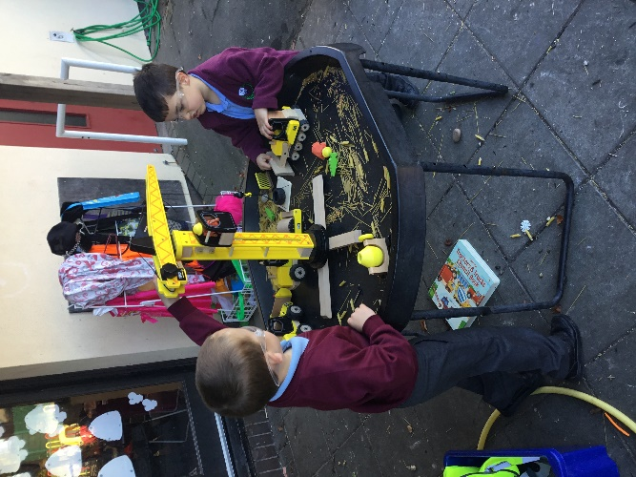At Maylandsea Primary School we strive to develop the children’s independence and resilience through the provision of a warm and welcoming environment. We ensure that every child’s interests are taken into consideration, thus allowing the children to achieve their full, unique potential. We foster strong relationships between adults and pupils and also encourage the children to develop key relationships with their peers. We believe that all children deserve to be valued as individual learners and it is our role as educators to guide them along their own learning path. As a school we aim to explore a range of experiences beyond village life to develop their awareness of other cultures and the wider world. We have high aspirations for the children and encourage them to challenge themselves.

PHOTO

**Implementation**

**Implementation**

**Our EYFS**

Our curriculum is based upon the standards set in the statutory EYFS Framework (2021) and supported by the non-statutory guidance of Development Matters (2021) alongside knowledge of our children, families, and local communities. We use the seven areas of Learning and Development to shape our curriculum. All these areas are important and interconnected. They are divided into prime and specific areas:

***Prime Areas***

* Communication and Language
* Physical Development
* Personal, Social and Emotional Development

***Specific Areas***

* Literacy
* Mathematics
* Understanding the World
* Expressive Arts and Design

Please follow this link to find out more about our EYFS curriculum.

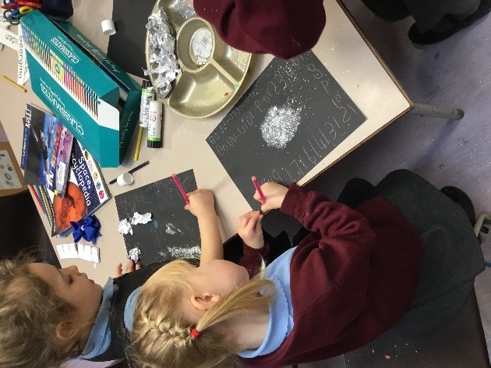We offer opportunities for planned, purposeful play, with a balance of adult-led and child-initiated activities both inside and outside. By tailoring our provision, we respond to the needs and interests of the children throughout the year to enable them all to achieve their unique potential.

PHOTO

***Play disarms fear, builds connectedness, and teaches social skills and competencies for life*.**

Dr Karyn Purvis

As outlined in the Statutory Framework for the EYFS (2021), the four guiding principles shape our practice:

* Every child is a **unique child**, who is constantly learning and can be resilient, capable, confident, and self-assured.
* Children learn to be strong and independent through **positive relationships.**
* Children learn and develop well in **enabling environments with teaching and support from adults**. Children benefit from a strong partnership between practitioners and parents and/or carers.
* Children develop and learn in different ways and at different rates.

***Play is often talked about as if it were a relief from serious learning. But for children, play is serious learning. Play is really the work of childhood.*** Fred Rogers

**The Role of the Adult**

Ofsted (2021) state that, ‘*Teaching should not be taken to imply a ‘top down’ or formal way of working. It is a broad term that covers the many different ways in which adults help young children learn*’.

The diverse and forever changing role of the adult in EYFS involves:

* High quality teacher led sessions
* Small group work
* 1-to-1 and group reading
* Weekly child focus approach
* Circle time activities
* Observing and assessing
* Interventions and booster groups

***Be the person you needed when you were younger*.**

Ayesha Siddiqi (2018)

Within our setting interactions between children and adults will look like this:

* Tuning in and discussing to establish what a child is thinking.
* Showing genuine interest.
* Respecting children’s own decisions and choices.
* Inviting children to elaborate.
* Recapping on what has happened.
* Offering personal experiences.
* Clarifying ideas.
* Supporting self-regulation and emotional well-being.
* Reminding and scaffolding.
* Using specific praise e.g., that is a good idea because…
* Offering an alternative viewpoint.
* Speculating/ using ‘I wonder if…’
* Promoting independence.
* Using and encouraging the use and understanding of new vocabulary.
* Modelling and participating in play.
* High quality and in-depth back and forth conversations.

**Our Environment**

Our environment is purposefully and carefully planned by considering: *Why? What for? Who for?* It is organised so children can locate equipment and resources independently. These are continuously available to enable pupils to revisit, rehearse, refine, and develop skills through exploration and involvement in all curriculum aspects. Enhancements are made to provision using overarching themes, children’s interests and current needs to stimulate pupil engagement and maximise development.

The outdoor area is as important as the indoor environment and is something we continue to develop, ensuring that we take our learning outside as much as possible, creating the links between the indoor and outdoor environments.

PHOTO

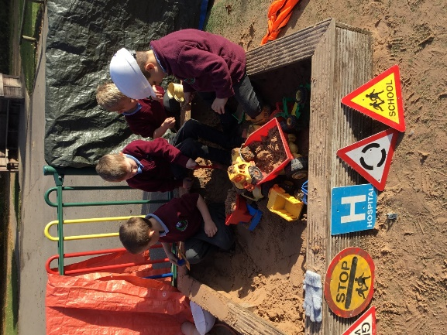Children learn best through familiarity; therefore, the classroom, activities and resources are designed with this in mind. For example, the domestic role-play, which is decorated differently throughout the year, provides the opportunity to learn about the lives, cultures, and celebrations of others in a relatable home setting. Reading, writing, and maths are interwoven throughout the environment so that it is purposeful and meaningful to the child in their chosen activity.

**Parents as Partners**

Parents are the first and most important influence on their child’s development and future outcomes. We recognise the past, present, and future role that parents play in educating their children. Children have two main educators in their lives – their parents and their teachers. The impact on a child’s education is greater if parents and schools work in partnership. Parents are encouraged to share significant information that could enable staff to best support their child’s needs and development. This includes information regarding medical history and involvement from external agencies.

***It is knowing the child and family that opens up endless possibilities for interactions that deepen the emotional bonds between a practitioner and a child, and lead, in turn, to educational opportunities to support and extend learning*.**

Julie Fisher (2016)

Some examples of how parents can support their children’s learning;

* Exploring the great outdoors.
* Having meaningful conversations.
* Reading with and to their child at home.
* Sharing a recap of your day and stories from your past.
* Playing together.
* Attending parent events e.g. phonics workshops, stay and plays, parents consultations.
* Engaging with various online platforms such as ClassDojo.

**We have an open-door policy and encourage parents to share any concerns, ideas, or questions.**

**Transition**

We are aware that Covid 19 may have impacted children’s wellbeing and the development of skills that will aid them in this transition to school. We will follow current government advice and adjust our support and practice to take this into account.

**Transition into Reception**

***Young children learn from those they trust and with those who foster enthusiasm for learning.*** Trevarthen (2002)

During the summer term, each registered child is invited to a selection of induction sessions. They will spend the sessions in the Reception learning environment getting to know the setting, adults and other children.

In addition, each family will be invited to a 1:1 meeting with the class teacher where they can share their child’s interests and abilities. This helps to build a relationship between the adults working with each child at school and at home and is an opportunity for the school to find out about each unique child.

PHOTO

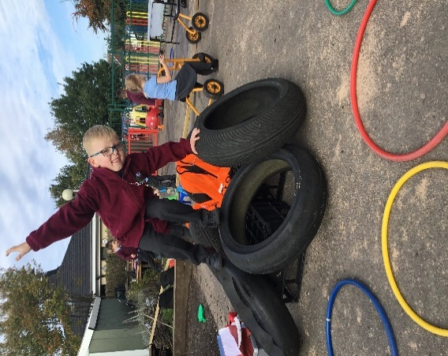To help build a relationship with each child, the class teacher will also visit them in their current pre-school/nursery setting. They will spend a brief amount of time to share information and have a look at their current learning journey. It is useful to see how the children behave in a setting and with individuals they are already familiar and comfortable with. The children feel special that their teacher has come to see them before they start school.

**Transition into Year** **One**

Building a strong relationship between the Reception children and their future Year One teacher(s) helps children to feel comfortable and ready for their next step.

In the autumn term, Reception children begin to become familiar with the Year One staff as both classes are involved in an EYFS/Key Stage One (KS1) nativity performance. In the spring term, this develops further as the children in Reception occasionally attend EYFS/KS1 assemblies. In the second half of the summer term, Reception children take part in KS1 break time. Additionally, when the induction for the new intake begins, children in the existing Reception class visit the Year One teacher for the afternoons.

PHOTO

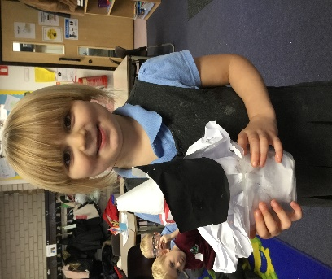Throughout the year, as a way to develop and maintain a relationship over time, the Reception and Year One teachers read stories, hold circle times and share news with their future and previous classes. This helps to establish bonds before children move to their next class and reminds those who have left, that they are still important to someone they don’t see each day and are not forgotten.

During the first term of Year One, the incorporation of continuous provision and learning challenges in a format similar to that of the EYFS curriculum, helps children to smoothly transition into KS1.

**Impact**

In our EYFS classroom, assessments are purposeful. They inform planning and facilitate children’s growth. Most assessment involves ongoing observations carried out whilst children are engaged in child-initiated activity/play and during focused group work/whole class teaching. This provides an insight into children's level of understanding related to specific skills and concepts. Assessments are based around progress towards our school’s individual EYFS curriculum goals to ensure children are fully prepared for their next stage in education.

Assessment opportunities include:

***High-level attainment comes from high-level engagement.*** Bryce-Clegg (2015)

* Statutory Reception Baseline Assessment (RBA).
* In-house baseline assessments of key skills, knowledge and well-being.
* Discussions with staff and children about their interests and their learning.
* Exchange of information with parents and previous settings to share an understanding of each child.
* 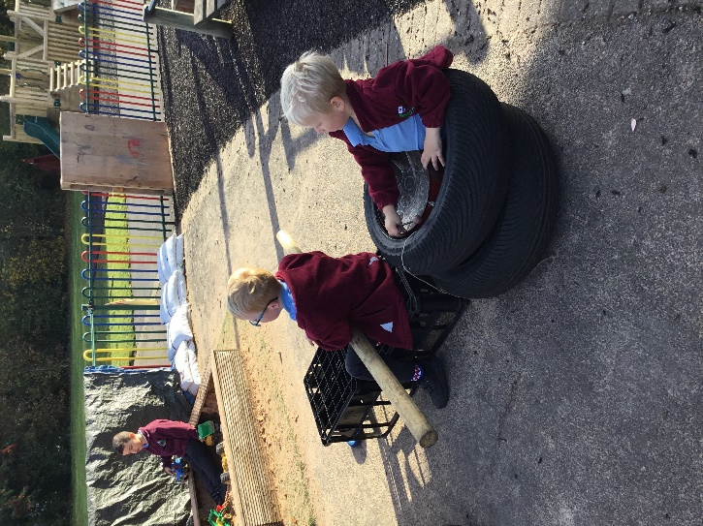The Eveleigh Link Academy Trust (TELAT) EYFS moderation.

In the final term of the Reception year, the EYFS Profile (EYFSP) will be completed by the teacher for every child. Children’s development will be assessed against each of the 17 Early Learning Goals (ELG) to determine if they have met the expected levels of development before moving into Year 1. This information will be discussed, along with their progress towards our school specific EYFS curriculum goals, with the Year 1 teacher as part of the transition process.

PHOTO

**Statutory and supporting documents**

We use the following statutory and non- statutory documentation to support and guide our practice:

* <https://www.gov.uk/government/publications/early-years-foundation-stage-framework--2>
* <https://www.gov.uk/government/publications/development-matters--2>
* <https://birthto5matters.org.uk/>
* <https://www.gov.uk/government/publications/early-years-foundation-stage-profile-handbook>