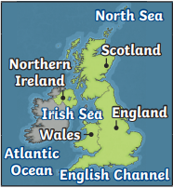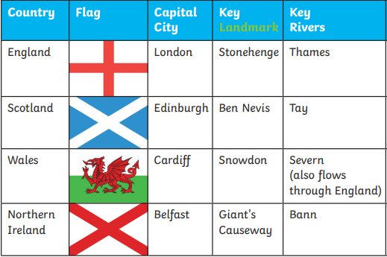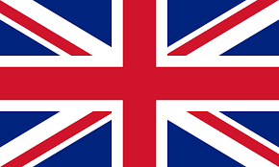

**Key Dates:**

6th May 2023 – King Charles’ Coronation

8th September 2022 – The Queen’s died

2nd June 1953 –Queen's Coronation

5th July 1948 – NHS founded

12th May 1820 – Florence Nightingale was born

Key Vocabulary-

Country, county, city, town, village, capital city

Landmark

Union Jack (the flag of Great Britain)

Heir to the throne (the next person in line to be King or Queen)

Coronation /Royal

Great Britain United Kingdom (UK)Europe

Key People-

King Charles iii

Queen Elizabeth ii and Prince Philip

Prince William and Princess Katherine

Prince Harry

King Henry VIII

Queen Victoria

Florence Nightingale

**Great Britain**