Maylandsea Primary School Pupil premium strategy statement 2023-2024

This statement details our school’s use of pupil premium to help improve the attainment of our disadvantaged pupils.

It outlines our pupil premium strategy, how we intend to spend the funding in this academic year and the effect that last year’s spending of pupil premium had within our school.

School overview
Detail | Data
School name | Maylandsea Primary School
Number of pupils in school | 242
Proportion (%) of pupil premium eligible pupils | 13% (32 pupils)
Academic year/years that our current pupil premium strategy plan covers (3 year plans are recommended) | 2021-2024
Date this statement was published | October 2021
Date on which it will be reviewed | October 2022  October 2023  October 2024
Statement authorised by | Mr J Figg
Pupil premium lead | Mrs C James
Governor / Trustee lead | Mrs L Austin
Funding overview
Detail | Amount
Pupil premium funding allocation this academic year | £35,138
Pupil premium funding carried forward from previous years (enter £0 if not applicable) | £0
Total budget for this academic year  If your school is an academy in a trust that pools this funding, state the amount available to your school this academic year | £35,138

Part A: Pupil premium strategy plan

Statement of intent
At Maylandsea Primary School, we believe that the highest possible standards can only be achieved by having the highest expectations of all learners. Some pupils from disadvantaged backgrounds require additional support; therefore, we will use all the resources available to help them reach their full potential, including the pupil premium grant (PPG).
The PPG was created to provide funding for three key areas:
• Raising the attainment of disadvantaged pupils and closing the gap with their peers.
• Providing funding for LAC and previously LAC (PLAC).
• Supporting pupils with parents in the armed forces.
Achieving our objectives:
In order to achieve our objectives and overcome identified barriers to learning we will:

➢ Provide all teachers with high quality CPD to ensure that pupils access effective
quality first teaching
➢ Provide targeted intervention and support to quickly address identified gaps in
learning including the use of small group work, 1:1 tuition
➢ Target funding to ensure that all pupils have access to trips, residential trips, first
hand learning experiences
➢ Provide opportunities for all pupils to participate in enrichment activities including sport and music
➢ Provide appropriate nurture support to enable pupils to access learning within and beyond the classroom.

This is not an exhaustive list and strategies will change and develop based on the needs of individuals.

Key Principals:
We will ensure that effective teaching, learning and assessment meets the needs of all pupils through the rigorous analysis of data. Class teachers will identify pupil progress meetings specific intervention and support for individual pupils which will be reviewed at least termly. Alongside academic support, we will ensure that those pupils who have social, emotional and mental health needs will access high quality provision from appropriately trained adults.

Challenges

This details the key challenges to achievement that we have identified among our disadvantaged pupils.
Challenge number | Detail of challenge
1 | Speech, language and communication skills
2 | Gaps in reading, phonics, writing and maths
3 | Access to wider opportunities
4 | Parental engagement
5 | Attendance and punctuality
6 | Mental health and well being

Intended outcomes
This explains the outcomes we are aiming for by the end of our current strategy plan, and how we will measure whether they have been achieved.
Intended outcome | Success criteria
Reading, Writing and Maths | Achieve outcomes in-line with, or above, national average by the end of KS2.
Phonics | Achieve outcomes in-line with, or above, national average of pupils in Y1 pass the PSC
Attendance | Ensure attendance of disadvantaged pupils is at least 96%
Wider Curriculum Opportunities | Children have access to wider experiences to broaden their curriculum entitlement

Activity in this academic year
This details how we intend to spend our pupil premium (and recovery premium funding) this academic year to address the challenges listed above.

Teaching (for example, CPD, recruitment and retention)
Budgeted cost: £12,620
Activity | Evidence that supports this approach | Challenge number(s) addressed
Chatterbugs | Pupils spoken language deficit effects their ability in Reading and Writing, which are below national expectations. Pupils who start at the school have low speech language and communication skills | 1
Structured maths intervention - Number Stack to be implemented across the school | Pupils’ attainment in Maths is below national expectations by the end of Y6 | 2
Phonics programme to be embedded across EYFS and KS1 | Phonics attainment is below national average | 2
Cover HLTA employed to release curriculum leaders | Continual improvement of the quality of the curriculum through lesson observation, book scrutiny and pupil voice | 2,3

Targeted academic support (for example, tutoring, one-to-one support structured interventions)
Budgeted cost: £13,200
Activity | Evidence that supports this approach | Challenge number(s) addressed
Precision teaching (Education Phycology Service) | Pupils’ attainment in reading, writing and maths is below national expectations by the end of Y6 | 2
Clicker 8 | Pupils’ attainment in Writing is below national expectations by the end of Y6 | 2
Cover teacher employed to release class teacher to provide small group tuition | Pupils’ attainment in reading Writing and Maths is below national expectations by the end of Y6 | 2
Catch Up reading | Pupils’ attainment in reading is below national expectations by the end of Y6 | 2
Widget | Support for PPG pupils with SEND needs | 1,2,3,4

Wider strategies (for example, related to attendance, behaviour, wellbeing)
Budgeted cost: £12,460
Activity | Evidence that supports this approach | Challenge number(s) addressed
Family Support worker employed to support families | Children are identified as being persistently absent. Children with poor attendance do not perform as well as children with good attendance | 4,2,1,6
Subsidised visits | Children from lower income families may not be able to attend school trips which will disadvantage their access to a broad and balanced curriculum | 3,2,6
Parental workshops | Positive parental engagement can support pupil progress and attendance | 1,2,3,4,5,6
After school club places provided | Every child should have the opportunity to learn to play an instrument/perform in front of an audience. | 3,6

Total budgeted cost: £35,138

Part B: Review of outcomes in the previous academic year

Pupil premium strategy outcomes
This details the impact that our pupil premium activity had on pupils in the 2022-2023 academic year.
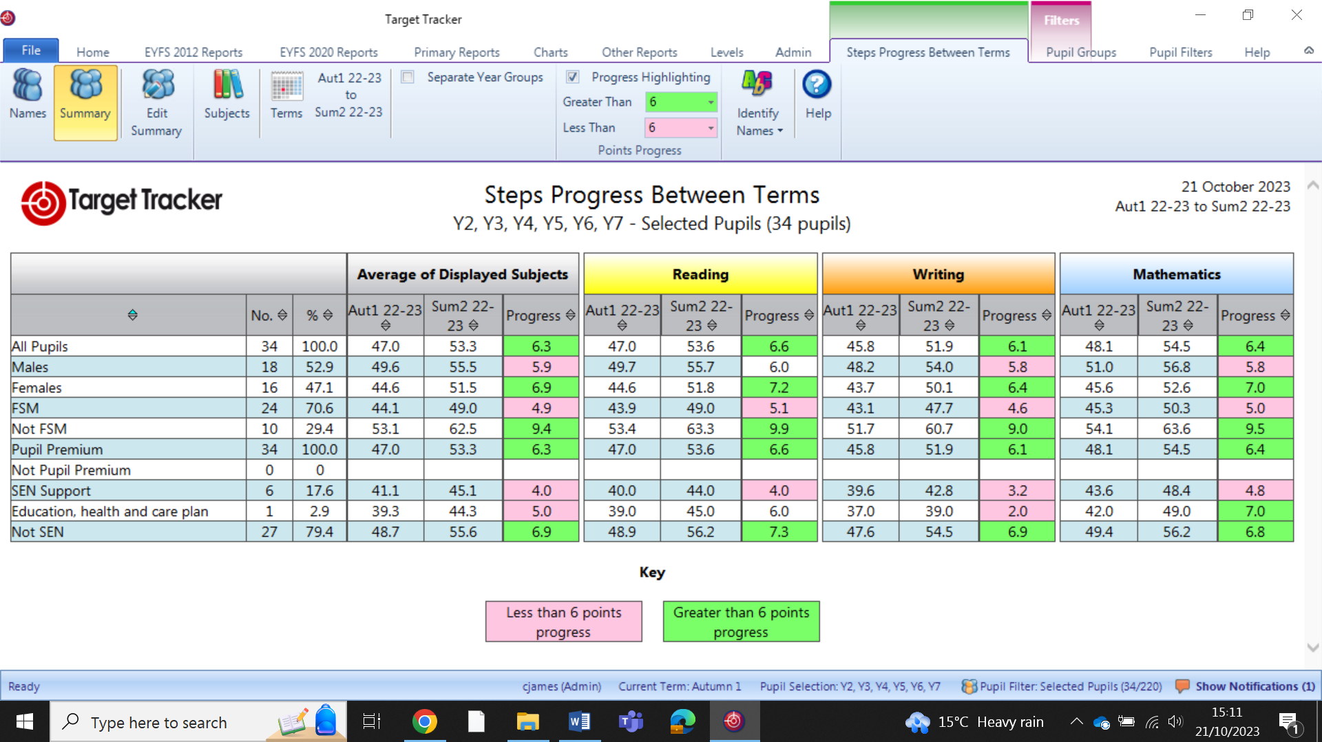

Externally provided programmes
Please include the names of any non-DfE programmes that you purchased in the previous academic year. This will help the Department for Education identify which ones are popular in England
Programme | Provider
TT Rockstars | Maths Circle Ltd
Bug Club | Pearson
My Maths | Oxford University Press
Catch up Reading | Catch Up Number
Widget | Rapid Readers

Service pupil premium funding (optional)
For schools that receive this funding, you may wish to provide the following information:
Measure | Details
How did you spend your service pupil premium allocation last academic year? | - 1:1 support for social and emotional needs  - Support in meeting other service children via zoom meetings  - Opportunity to speak to parents on tour via zoom
What was the impact of that spending on service pupil premium eligible pupils? | - Children were supported with their mental health and well-being needs  - Children were supported in their learning and made good progress in their learning

