Maylandsea Primary School Pupil premium strategy statement 2023-2024

This statement details our school’s use of pupil premium to help improve the attainment of our disadvantaged pupils.

It outlines our pupil premium strategy, how we intend to spend the funding in this academic year and the effect that last year’s spending of pupil premium had within our school.

School overview
Detail | Data
School name | Maylandsea Primary School
Number of pupils in school | 228
Proportion (%) of pupil premium eligible pupils | 13% (29 pupils)
Academic year/years that our current pupil premium strategy plan covers (3 year plans are recommended) | 2022-2025
Date this statement was published | October 2024
Date on which it will be reviewed | October 2025
Statement authorised by | Mr J Figg
Pupil premium lead | Mrs C James
Governor / Trustee lead | Mrs L Austin
Funding overview
Detail | Amount
Pupil premium funding allocation this academic year | £43,600
Pupil premium funding carried forward from previous years (enter £0 if not applicable) | £0
Total budget for this academic year  If your school is an academy in a trust that pools this funding, state the amount available to your school this academic year | £43,600

Part A: Pupil premium strategy plan

Statement of intent
At Maylandsea Primary School, we believe that the highest possible standards can only be achieved by having the highest expectations of all learners. Some pupils from disadvantaged backgrounds require additional support; therefore, we will use all the resources available to help them reach their full potential, including the pupil premium grant (PPG).
The PPG was created to provide funding for three key areas:
• Raising the attainment of disadvantaged pupils and closing the gap with their peers.
• Providing funding for LAC and previously LAC (PLAC).
• Supporting pupils with parents in the armed forces.
Achieving our objectives:
In order to achieve our objectives and overcome identified barriers to learning we will:

➢ Provide all teachers with high quality CPD to ensure that pupils access effective
quality first teaching
➢ Provide targeted intervention and support to quickly address identified gaps in
learning including the use of small group work, 1:1 tuition
➢ Target funding to ensure that all pupils have access to trips, residential trips, first
hand learning experiences
➢ Provide opportunities for all pupils to participate in enrichment activities including sport and music
➢ Provide appropriate nurture support to enable pupils to access learning within and beyond the classroom.

This is not an exhaustive list and strategies will change and develop based on the needs of individuals.

Key Principals:
We will ensure that effective teaching, learning and assessment meets the needs of all pupils through the rigorous analysis of data. Class teachers will identify pupil progress through pupil progress meetings to identify specific interventions and support for individual pupils which will be reviewed at least termly. Alongside academic support, we will ensure that those pupils who have social, emotional and mental health needs will access high quality provision from appropriately trained adults.

Challenges

This details the key challenges to achievement that we have identified among our disadvantaged pupils.
Challenge number | Detail of challenge
1 | Communication and interaction:  Disadvantaged pupils (some) in the EYFS have lower than typical starting points when entering reception.
2 | Gaps in Curriculum Knowledge:  Underdeveloped oral language skills and vocabulary gaps among many disadvantaged pupils. These are evident from Reception through to KS2 and in general, are more prevalent among our disadvantaged pupils than their peers whether or not the family speaks English at home.  Greater difficulty with phonics in comparison to non-disadvantaged pupils. This negatively impacts their development as readers.  Assessments indicate that reading, writing and maths attainment among our  disadvantaged pupils is below that of non-disadvantaged pupils.  Our assessments and observations suggest that a substantial number of Pupil Premium children have additional vulnerabilities such as Special Educational Needs and/or English  as an Additional Language and therefore require additional interventions.  Some of our families from disadvantaged backgrounds have difficulty with supporting their children with their home learning due to their own gaps in curriculum knowledge.
3 | Access to wider life experiences:  Some of our disadvantaged pupils have less access to books, stories, conversations, games and toys at home and have limited exposure to activities or outings.  Some of our children from disadvantaged backgrounds lack the opportunities for wider experiences causing a lack in cultural capital in comparison to their non-disadvantaged  peers.
4 | Parental engagement Financial difficulties:  Some of our children from disadvantaged backgrounds may have financial difficulties:  With purchasing school uniforms.  With affording to take children on wider experiences that families from non-disadvantaged backgrounds can afford.  With affording healthy, nutrient rich food.
5 | Attendance and punctuality: Regular punctual attendance is a challenge  for a small minority of our disadvantaged pupils  Persistent absence to be reduced to below 1% and for attendance to be  in line with all pupils.
6 | Social and emotional wellbeing:  A high proportion of our disadvantaged pupils have emotional needs due to family circumstances and may require social, emotional and behavioural support. Many also lack confidence and self-esteem.  Our observations and links to families suggest that there are issues with overcrowded or poor housing which can have an adverse impact on sleep quality, punctuality, attendance of our disadvantaged pupils.

Intended outcomes
This explains the outcomes we are aiming for by the end of our current strategy plan, and how we will measure whether they have been achieved.
Intended outcome | Success criteria
Improved oral language skills and vocabulary among disadvantaged pupils. | Assessments and observations indicate significantly improved oral language among disadvantaged pupils. This is evident when triangulated with other sources of evidence, including engagement in lessons, book scrutiny and ongoing formative assessment.
Improved reading and writing attainment among disadvantaged pupils. | KS2 reading and writing outcomes in 2024/25 show that more disadvantaged pupils meet the expected standard and the gap is diminished compared to their non-disadvantaged peers.
Improved maths attainment for disadvantaged pupils at the end of KS2. | KS2 maths outcomes in 2024/25 show that more disadvantaged pupils meet the expected standard and the gap is diminished compared to their non-disadvantaged peers.
To achieve and sustain improved wellbeing for all pupils in our school, particularly our disadvantaged pupils. | Sustained high levels of wellbeing from 2024/25 demonstrated by:  qualitative data from student voice, student and parent surveys and teacher observations  a significant increase in participation in enrichment activities, particularly among disadvantaged pupils
To improve access to wider life experiences for our disadvantaged pupils. | More children from disadvantaged families will go on school trips and take part in after school clubs that will enrich their lives.
To achieve and sustain improved  attendance for all pupils,  particularly our disadvantaged  pupils. | Sustained high attendance from 2024/25 demonstrated by the overall absence rate for all pupils and the attendance gap between disadvantaged pupils and their non-disadvantaged peers being reduced.

Activity in this academic year
This details how we intend to spend our pupil premium (and recovery premium funding) this academic year to address the challenges listed above.

Teaching (for example, CPD, recruitment and retention)
Budgeted cost: £12,620
Activity | Evidence that supports this approach | Challenge number(s) addressed
Chatterbugs  LSA support time to run intervention for EYFS / Year 1 pupils  £100 x 36 = £3600 | Pupils spoken language deficit effects their ability in Reading and Writing, which are below national expectations. Pupils who start at the school have low speech language and communication skills | 1
Continues purchase of a DfE validated Systematic Synthetic Phonics programme (Essential Letters and Sounds) to secure stronger phonics teaching for all pupils across EYFS - and KS2. | Continued training for all teaching and support staff. Phonics approaches have a strong evidence base that indicates high impact on the accuracy of word reading (though not necessarily comprehension), particularly for disadvantaged pupils (+5 months)  Phonics | Toolkit Strand | Education Endowment Foundation | EEF | 2
Structured maths intervention - Number Stacks to be implemented across the school  £25 per subscription  X 30 = £750  Subsiding cost of Y6 SATs revision books to provide additional academic support at home.  Enhancement of our maths teaching and  curriculum planning in line with DfE and EEF  guidance. | Pupils’ attainment in Maths is below national expectations by the end of Y6  Pupils eligible for free school meals typically receive additional benefits from homework. Providing revision books, rather than online tasks, ensure that children from disadvantaged backgrounds will be able to access the additional support regardless on any difficulties they may face in accessing technology at home.  Renew subscription to White Rose maths planning resources.  The DfE non-statutory guidance has been produced in conjunction with the National Centre for Excellence in the Teaching of Mathematics, drawing on evidence-based approaches:  Maths_guidance_KS_1_and_2.pdf  (publishing.service.gov.uk)  The EEF guidance is based on a range of the best available evidence:  Improving Mathematics in Key Stages 2 and 3 | 2
Cover HLTA employed to release curriculum leaders  HLTA ½ day per week to release teachers £100 x 36 = £3600 | Continual improvement of the quality of the curriculum through lesson observation, book scrutiny and pupil voice | 2,3
TPP training for all staff  3 days train the trainer 7 elements for all staff to complete  3 x £200 = £600 | Trauma Perspective Practice  Supports staff to provide an environment which promotes the sense of belonging.  • Enables staff to be more knowledgeable and skilled to effectively support pupils.  • Enables staff to be aware, understand and meet the pupils’ emotional needs so that they can make progress with their learning.  • Enables staff to have healthy and helpful conversations with each other using reflective practice.  • Creates an underlying culture of respect and support so that pupils are provided with clear expectations.  • Develops an understanding of co-regulation/self-regulation to guide them through stressful situations.  • Enables the school/setting to realise the prevalence and impact of trauma and respond by building resilience, relationships and safety for children, families and staff. | 5/6
Structured literacy intervention – Dyslexia Gold to be implemented across the school  £25 per subscription  X 30 = £750 | Pupils’ attainment in writing is below national expectations by the end of Y6 | 2

Targeted academic support (for example, tutoring, one-to-one support structured interventions)
Budgeted cost: £13,200
Activity | Evidence that supports this approach | Challenge number(s) addressed
Precision teaching (Education Phycology Service) | Pupils’ attainment in reading, writing and maths combined is below national expectations by the end of Y6 | 2
Number stacks | Pupils attainment in maths is currently below national expectation by the end of Year 6 | 2
Dyslexia Gold | Pupils’ attainment in Reading Writing and Maths combined is below national expectations by the end of Y6 | 2
Catch Up reading | Pupils’ attainment in reading is below national expectations by the end of Y6 | 2
ELS phonics small group intervention | Pupils attainment in phonics is now above national expectations. | 2

Wider strategies (for example, related to attendance, behaviour, wellbeing)
Budgeted cost: £12,460
Activity | Evidence that supports this approach | Challenge number(s) addressed
Family Support worker employed to support families | Children are identified as being persistently absent. Children with poor attendance do not perform as well as children with good attendance | 4,2,1,6
Fund educational visits and extracurricular activities for pupils eligible for pupil premium. Providing a range of rich experiences beyond children’s own lives. | We want all pupils to be able to participate in high-quality educational visits and experiences in order to broaden the experiences of children from disadvantaged backgrounds. These experiences will help to widen prospects and horizons for all of our children, in particular, those from disadvantaged backgrounds:  School trips and visits  Y6 Residential  Range of after school clubs / lessons where children from disadvantaged backgrounds will be given the same access to funded clubs as their non-disadvantaged peers | 3,2,6
Parental workshops  To provide parent workshops  to support families with  strategies to support their  children at home with their  learning and social and  emotional well being.  Cost: Staff meeting  time/PPPA | Positive parental engagement can support pupil progress and attendance EEF Tool Kit  EEF Guide to Pupil Premium  Effective communication with parents will play a vital part in linking the  school to the home, particularly in relation to any future localised lock downs.  Plan and review all channels of communication to ensure these impact  sufficiently upon pupils and wider engagement. | 1,2,3,4,5,6
After school club places provided | Every child should have the opportunity to learn to play an instrument/perform in front of an audience. | 3,6

Total budgeted cost: £35,138

Part B: Review of outcomes in the previous academic year

Pupil premium strategy outcomes
This details the impact that our pupil premium activity had on pupils in the 2023-2024 academic year.
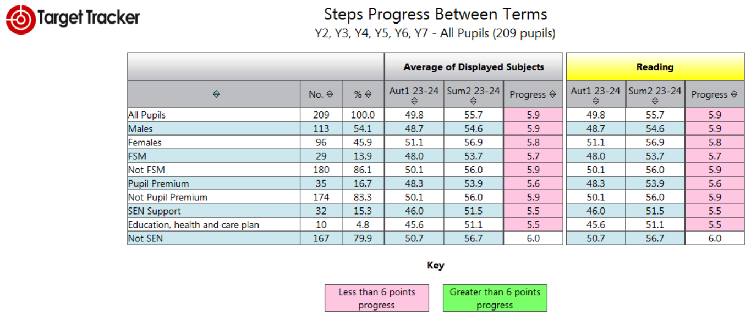

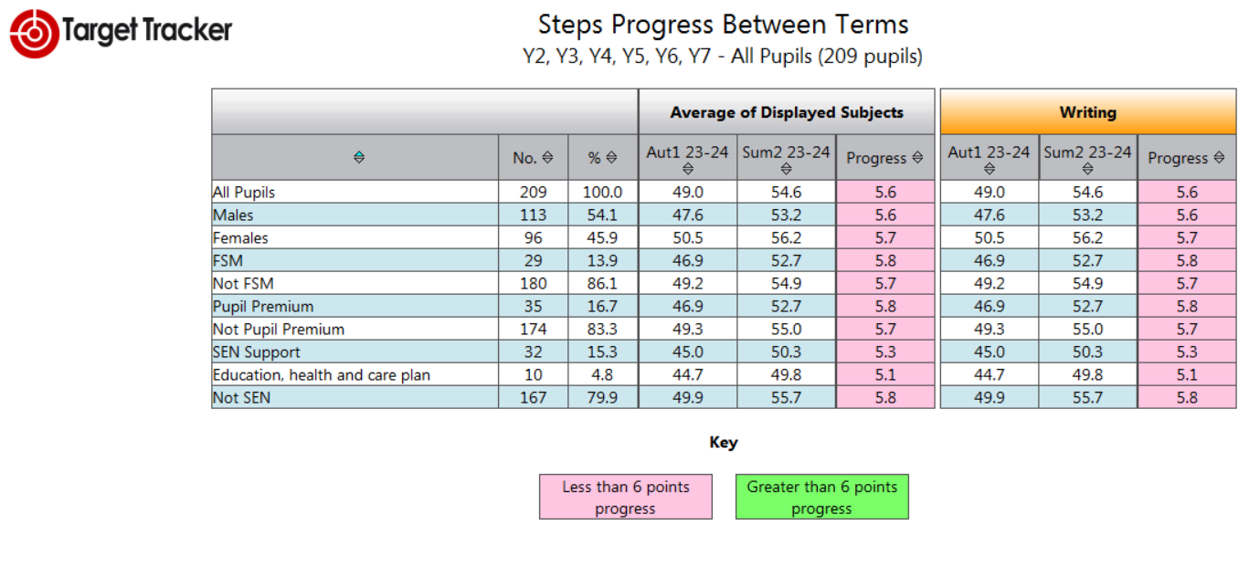
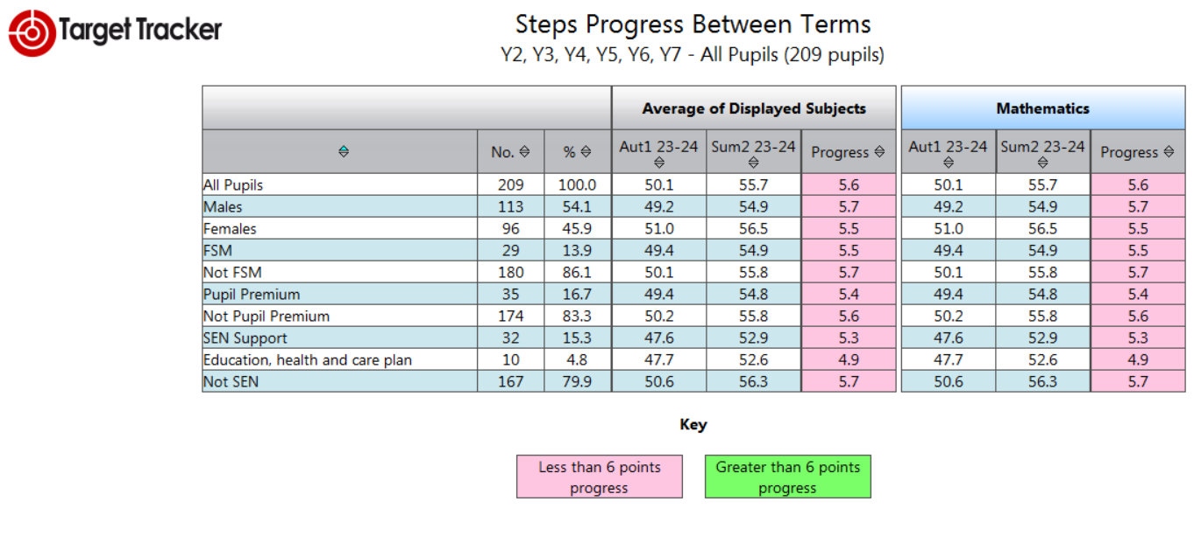

Externally provided programmes
Please include the names of any non-DfE programmes that you purchased in the previous academic year. This will help the Department for Education identify which ones are popular in England
Programme | Provider
TT Rockstars | Maths Circle Ltd
Oxford Owl | Oxford University Press
My Maths | Oxford University Press
Catch up Reading | Catch Up Literacy
Rapid Readers | Pearson
Number Stacks | Number Stacks
Literacy Gold | Dyslexia Gold
Relax Kids | Relax Kids
Desty Island | Desty
Sensory Circuits | Children’s Choice Therapy Service LTD

Service pupil premium funding (optional)
For schools that receive this funding, you may wish to provide the following information:
Measure | Details
How did you spend your service pupil premium allocation last academic year? | - 1:1 support for social and emotional needs  - Support in meeting other service children via zoom meetings  - Opportunity to speak to parents on tour via zoom
What was the impact of that spending on service pupil premium eligible pupils? | - Children were supported with their mental health and well-being needs  - Children were supported in their learning and made good progress in their learning

