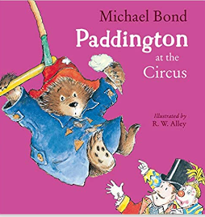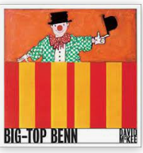

Key People and Dates-

[Philip Astley](http://www.circopedia.org/Philip_Astley) (1742-1814),

[PT Barnum](http://www.circopedia.org/index.php?title=Phineas_Taylor_Barnum&action=edit&redlink=1) (1810-1891)

Bertram Mills 1873 – 1938)

Cirque de soleil 1894

**Key Vocabulary-**

Animal rights Ring master Performers

Acrobats, clowns, dancers, tightrope, performance, audience, applause, trapeze

The Big Top Cirque de soleil

**The Travelling Circus over the years-**

train, cart, wagon, horses, road, walking, cage

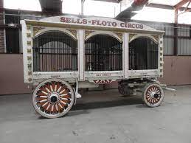

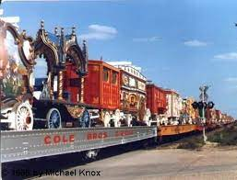

**The Circus is in Town!**