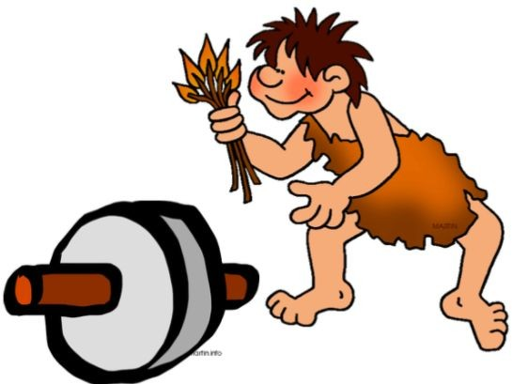Year 3 History: How did life in Britain change between the Stone Age and the Iron Age?

# Key Topics: Life in the early Stone Age, Skara Brae, neolithic monuments, Life in the Bronze Age, Stonehenge, Life in the Iron Age, Continuity and Change

|  |  |
| --- | --- |
| **Key Vocabulary** | |
| AD | This stands for Anno Domini, Latin for in the year of our Lord, and is used with dates to show that something happened after Jesus was born. |
| archaeologist | An archaeologist learns about the past by digging up and studying remains and objects left behind. |
| artefact | A man-made object left behind by the past. |
| barrow | A mound of earth built over a Stone Age burial site. |
| BC | This stands for Before Christ and is used with dates to show that something happened before Jesus was born. |
| domesticate | To domesticate an animal is to tame it. |
| flint | A hard-grey rock, used in prehistoric times to make tools or weapons. |
| henge | A prehistoric monument made up of a circle of stones or wooden pieces standing upright. |
| hill forts | A wooden fort built on a hill and lived in by Iron Age people. |
| hunter-gatherers | People who are hunter-gatherers travel about finding food by fishing, hunting and gathering wild food. |
| nomadic | Someone who is nomadic has no settled home and travels from place to place to find food. |
| prehistory | Everything that happened before the written record began. |
| round houses | A circular house built by Iron Age people out of wattle (sticks) and daub (mud). |

**People and Places**

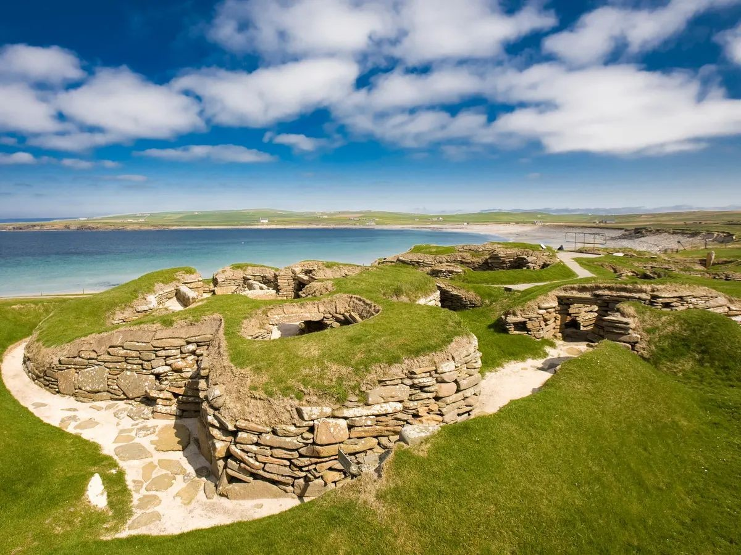 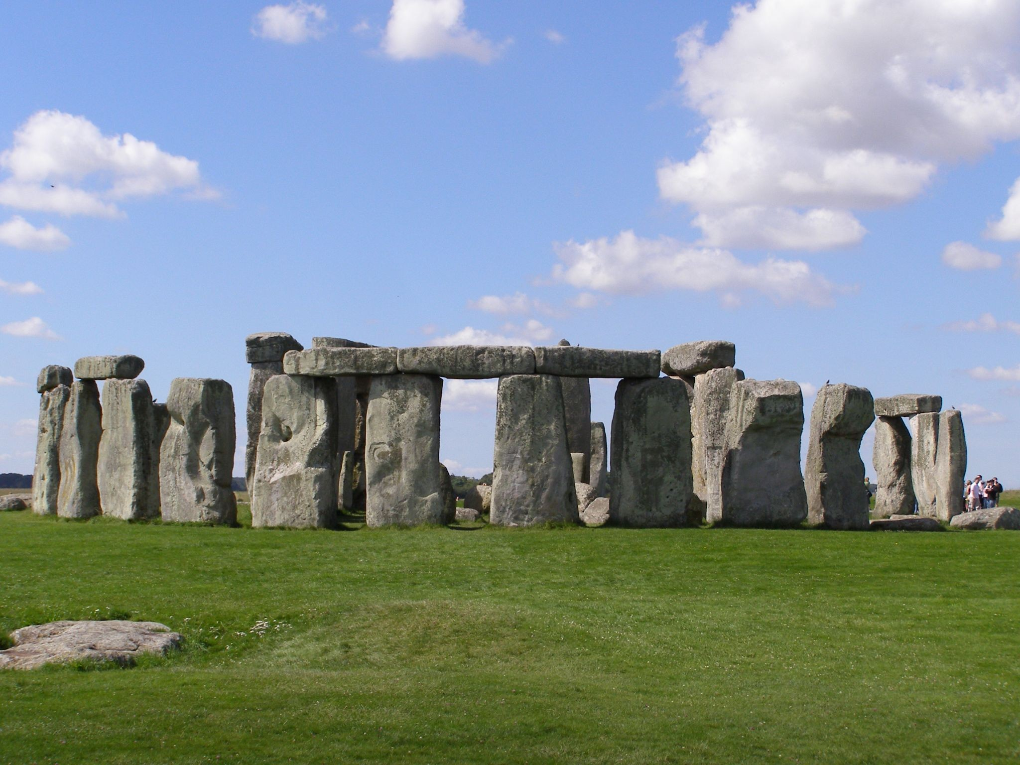

Skara Brae is a late Stone Age village on the island of Orkney, off the coast of Scotland. People lived there over 5,000 years ago and the remains of the village can still be explored today.

Stonehenge is a world-famous prehistoric monument about 80 miles west of London. It was built between 3,000 and 1,500 BC. It is made up of over 100 large stones and was probably used for religious ceremonies.

People arrived from Europe in wooden boats and settled, bringing new technologies to Britain. The Beaker people arrived around 2,500 BC bringing pottery and metalworking skills with them. Around 400 BC Celts arrived. The Celts were very skilled metal workers and also brought with them dyes that enabled people to make brightly coloured cloth.

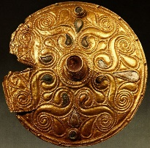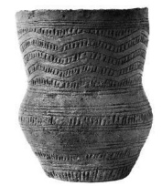

Beaker pottery

Celtic Metal work

Early Stone Age 10,000 - 4000 BC

**Paleolithic** Era

People were hunter-gatherers

Late Stone Age 4,000 - 2,500 BC

**Neolithic** Era

People began to farm. Stonehenge was built.

Bronze Age 2,500 BC - 800 BC

People began to mine and made metal objects.

Iron Age 800 BC - 43AD

Iron objects are made, larger settlements and hill forts are built.

10,000 BC

7,500 BC

5,000 BC

2,500 BC

0AD