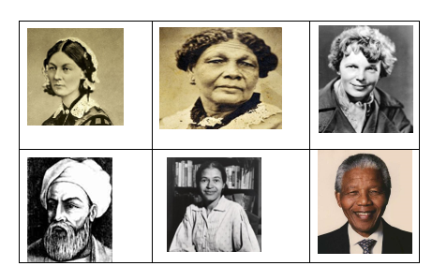
Key Vocabulary
- Past
- Present
- Before
- After
- Then
- Now
- hero
- heroine
- fair
- unfair
- equality
- journey
- explore
- change
- help
- brave

Key Time Periods
- Florence Nightingale – long ago (Victorian times)
- Mary Seacole – long ago (Victorian times)
- Amelia Earhart – not so long ago
- Ibn Battuta – a very long time ago
- Rosa Parks – within living memory
- Nelson Mandela – within living memory

Key Themes
- helping others
- exploring the world
- fairness and equality
- making a difference
- change over time

Key Questions
- Who were these people?
- What did they do?
- Why are they important?
- How did they help or change the world?

Key People
- Florence Nightingale – helped soldiers and improved hospitals
- Mary Seacole – cared for soldiers and travelled to help
- Amelia Earhart – first woman to fly across the Atlantic Ocean
- Ibn Battuta – travelled to many countries and wrote about what he saw
- Rosa Parks – stood up for fairness and helped change rules
- Nelson Mandela – helped to change unfair laws

